**Actual and Perceived Political Knowledge: Relative Effects on Participation**

Kristin Bail *April 18, 2018*

**Summary:** Social scientists have generally conceived of knowledge in terms of “objective” knowledge, where “objective” means using measures researchers consider appropriate for the time and context. This has resulted in dozens of knowledge scales to use, with one of the most common rating respondents in terms of their abilities to answer self-selected factual questions. I henceforth refer to these measures as measures of actual knowledge, albeit knowledge that I deem important.

Studies in social psychology highlight two other possible ways to think about citizens’ political knowledge: 1) their perceptions of how much they know without respect to others, and 2) their perceptions of how much they know vis-à-vis others.

To test whether and how objective political knowledge, perceptions of how much people think they know irrespective of others, and their perceptions of how much they know relative to peers impact and predict political participation and efficacy, I fielded a survey in the university subject pool containing questions relevant to each domain and tailored to the experiences of the typical undergraduate. The survey yielded 269 usable results.

**Introduction**

In their classic examination of political participation, Brady, Verba, and Schlozman (1995) conclude citizens do not take part in politics “because they can’t, because they don’t want to, or because nobody asked” (p. 271). While their study focuses on the resources associated with political participation, the second of their explanations highlights the role of psychological engagement with politics. People may not participate for reasons ranging from a lack of interest and negligible concern with public issues to the belief that their activity has little impact. The last of these issues relates to feelings efficacy, a key construct used to examine and explain several aspects of political behavior.

Many studies present evidence for political knowledge as a predictor of political participation, the idea being that political knowledge raises internal political efficacy and indirectly increases the chances of a citizen’s participating politically. Scholars tend to conceive knowledge in terms of “objective” knowledge, where “objective” means using measures researchers consider appropriate. However widespread its use, what we know of knowledge is incomplete. Were a person’s knowledge truly a perfect predictor of efficacy and participation, studies would show the most knowledgeable people consistently participating at the highest rates and having the greatest senses of both internal and external efficacy. As that is not the case, it is more likely that real or objective knowledge is simply one dimension to which we need to pay attention in the greater participation game.

**Brief Literature Review/Rationale:**

Political knowledge, or what we know about politics, is integral to research on political behavior, touching everything from vote choice and turnout to personal levels of tolerance and ideology. But what the field collectively knows about this construct is rooted in dozens of different indicators of knowledge, all crafted according to what the researcher finds most appropriate for the given subject and context. In determining who is informed, scholars have crafted measures of “objective” knowledge that focus on formal education (Delli Carpini and Keeter 1996), cognitive ability (Luskin 1990), or partisan motivation (Jerit and Barabas 2012; Parker-Stephen 2013). Political science has relied heavily on the five-item knowledge battery originally proposed by Delli Carpini and Keeter (1996), but it is not unusual for researchers to construct knowledge scales from scratch, using study-specific items as evidence for their findings (e.g. Prior and Lupia 2008, Shaker 2012).

Upon its first introduction, political efficacy was measured unidimensionally. Gradually, however, theoretical and empirical developments resulted in the emergence of two distinct dimensions: internal efficacy, which relates to citizens’ feelings of personal competence “to understand and participate effectively in politics” (Craig, Niemi, and Silver 1990, p. 290), and external efficacy, which refers to citizens’ perceptions of the responsiveness of political bodies and actors to citizens’ demands (Balch 1974, Converse 1972).

Citizens’ actual knowledge is typically framed as a strong predictor of political participation. Scholars reason that the most knowledgeable in a population, wielding their arsenal of facts, feel better equipped to interact with the political apparatuses than their lower scoring counterparts and, buoyed by this confidence, feel more empowered to participate. While this is certainly the case for some individuals, this logic only carries so far. Participation rates among highly knowledgeable people are lower than their scores might predict, implying the influence of some variable political scientists have thus far failed to measure.

**The Role of Perception**

In their study of why individuals routinely miscalibrate their abilities, Dunning and Kruger (1999) find that, when assessed in a domain in which knowledge, wisdom, or savvy is a crucial component, participants scoring in the bottom quartile of respondents grossly overestimated their test performance and ability while those scoring in the top quartile systematically underestimated their own test performance. The inaccurate self-assessment of respondents stems from two sources: 1) the over-/underestimation of their own abilities, and 2) the over-/underestimation of the skills of their peers. Although the results of the study have found a variety of applications, Dunning and Kruger’s conclusions show how inaccurately people place themselves within a broader context irrespective of their knowledge levels or abilities.

Their findings additionally shine light on two key components with the potential to mediate both political efficacy and participation—the way people perceive their own abilities and their perceptions of those abilities relative to others. Internal efficacy is commonly defined as “beliefs about one’s own competence to understand, and to participate effectively in, politics” (Nieme et. al, 1991). That political knowledge is a good but imperfect predictor of key political behaviors such as participation could be explained by the mediating influence of these two levels of perception. If people believe themselves to be less able to comprehend politics than others, regardless of their true abilities, this belief may dampen their likelihood to participate. Conversely, an inflated sense of ability relative to others could potentially increase a person’s propensity to participate. The influence of both a person’s perception of their self-knowledge and the perception of how much they know relative to others could be non-trivial mediators between measures of actual knowledge and political participation.

**The Survey**

The survey was fielded in March 2018 and completed by undergraduates enrolled in political science classes in exchange for extra credit. Of the 552 people to participate in the subject pool for this semester, only 269 completed the full battery of questions specific to my survey. The high attrition rate is likely connected to the survey being fielded in the week immediately before the spring break holiday. Of those to complete the survey, 240 identified political science as their major field of study.

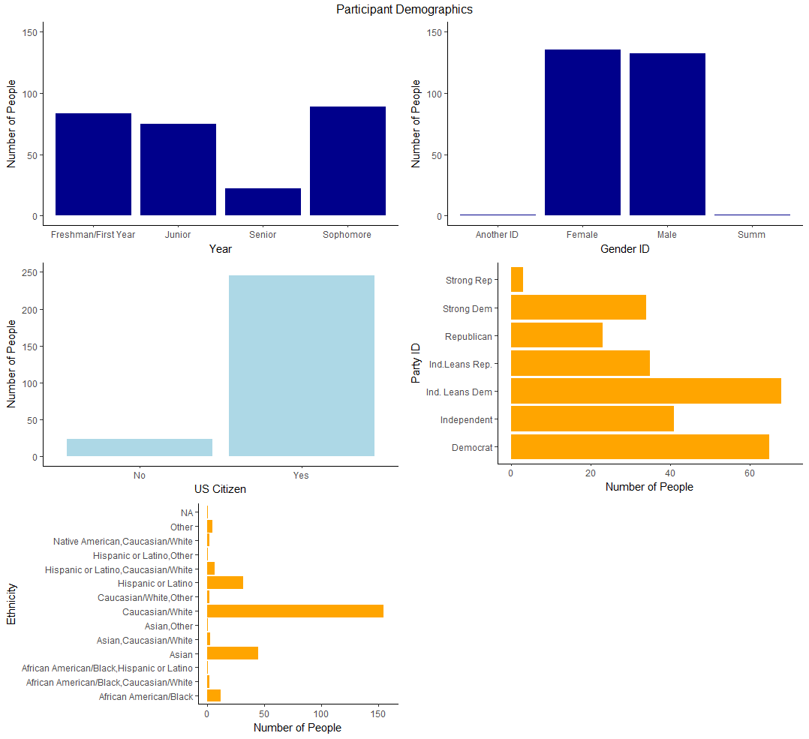

The sample population consists of largely U.S. citizens, with the largest sectors identifying as Caucasian/White and either independents leaning Democrat or fully Democratic. They are all undergraduate students taking part in the university subject pool. Were the aim of this paper to generalize to a population larger than the one sampled, the representativeness of survey respondents might be a cause for concern. Rather than attempting to make broad generalizations, however, what I am really trying to do is estimate the variation of something I care about, and in this case that is the variation in individual-level measures of efficacy and propensity to participate. Although the sample population is by no means representative of the United States or even the state of Illinois in terms of demographics or political knowledge, we expect perception of both your own knowledge and the knowledge of others to influence people to some degree, regardless of who they are or how much they know. So even though the sample may not be ideal in terms of composition, there is still much to be learned about the role of perception in moderating political behavior.

**Measures**

The survey asked a total of forty questions targeting the areas of real knowledge, perceived self-knowledge, knowledge vis-à-vis others, both internal and external efficacy, and political participation.

**Causal Variables**

1) respondent’s actual knowledge—number of questions answered correctly as part of the political knowledge portion of the survey. The nine questions connected to current policy issues prominent in the news cycle as well as non-controversial static political facts. Respondents’ “real” knowledge is measured in terms of how many questions correct. To avoid potential priming effects, I placed the real knowledge questions at the end of the survey.

2) Perceptions of how much they know without respect to others—how much they think they know. I targeted this construct through two separate measures: four questions relating to political information efficacy, rated on a scale of 1 (strongly disagree) to 10 (strongly agree), and three asking to what extent students believe they have the ability to partake in a campus activity such as running for and sitting on the UI student, with possible answers being “Definitely have the knowledge and ability,” “Probably have the knowledge and ability,” “Probably do not have the knowledge and ability,” and “Definitely do not have the knowledge and ability.”

3) Perceptions of how much they know vis-à-vis others—how much they think they know compared to other undergraduates. I measured this construct using the three above questions measuring perceptions of self-knowledge but framed as “compared to other UI undergraduates...” and with answers of “Have much more knowledge and ability,” “have somewhat more...,” “have somewhat less...,” and “have much less...”.

**Outcome Variables**

Political efficacy— belief about one’s own ability to understand and competently engage in politics. To answer this I used the question “How would you rate your general ability to understand politics,” with possible answers being “very high,” “high,” “low,” and “very low”. I also asked five questions typically used as measures of both internal and external political efficacy, i.e. “Voting gives people like me some say about how the government runs things,” with responses ranging from 1 to 10, 10 being “strongly agree”. I average the scores across five questions to make one composite outcome variable.

Participation—because most university students have not had the same opportunities to participate politically as many older adults, I included questions targeting two dimensions of political participation. One relates to “traditional” participation such as voting and campaigning in local, state, and federal elections. The second asks students to rate on a scale of 1 to 10, with 10 being very likely, their likelihood of participating in university level political activities such as running for office in student government or a leadership position in a campus organization.

**Descriptive Statistics**

table of descriptive statistics about here

After recoding and cleaning the data, I calculated the descriptive statistics for the variables of interest and sorted individuals’ responses into bins of high and low on measures of real knowledge, perceived self-knowledge, and perceived knowledge vis-a-vis others. Those scoring “low” on real knowledge answered fewer than the mean of 6.32 questions correct. For measures of perceived self- and relative knowledge, students are similarly sorted into “high” and “low”.

The sorting process results in the above binning. Respondents appear to feel they know a great deal about politics, both generally and relative to others. Although the single largest category consists of people who perceive themselves correctly as scoring high in terms of actual knowledge, there are also respondents who score high in objective knowledge but rank themselves low in perceived self- and relative knowledge levels. There are additionally a large number of participants who, though falling into the low objective measures category, perceive themselves otherwise.

This spread amongst respondents leads to the questions of “what comparisons am I making?” I care about variation in the dependent variables and their influence on political efficacy and likelihood to participate. The most logical comparisons, then, would be between all participants with high-scoring objective knowledge measures, all low-scoring real knowledge respondents, and high and low knowledge individuals.

**The Role of Causality**

Where there might be room for determining causality in a future project, this paper is limited to investigating associational relationships between the observed variables. As such, some approaches to analysis provide more utility than others. Because there is no treatment, tools relating to hypothesis testing and permutation provide little insight into the relationships in question. Additionally, because the distribution of many of the variables appear to be skewed or unimodal, thus violating the assumption of a normal distribution, OLS regression would produce biased estimates of the relevant coefficients. Further, as this is an individual-level survey, using clustered standard errors is unnecessary.

A potential approach to making the right comparisons is through matching. Given the spread of the data and what past research has told the field about political knowledge, efficacy, and participation, it is highly likely that this approach would isolate not the role of my explanatory variables, but some other observed covariate such as race or gender, with male or Caucasian respondents more likely to feel efficacious and participate than those identifying as female or a person of color. Because gender and ethnicity are observed covariates likely to influence both the dependent and independent variables and I do not want to waste data, I plan to find a regression that will work given the distribution and assumptions of my data to determine the associations between all of my variables.

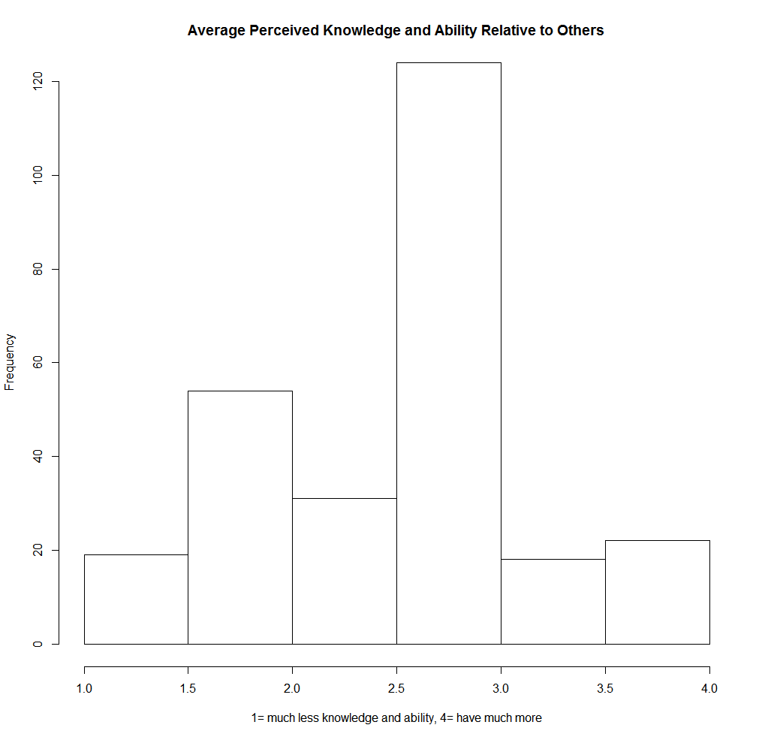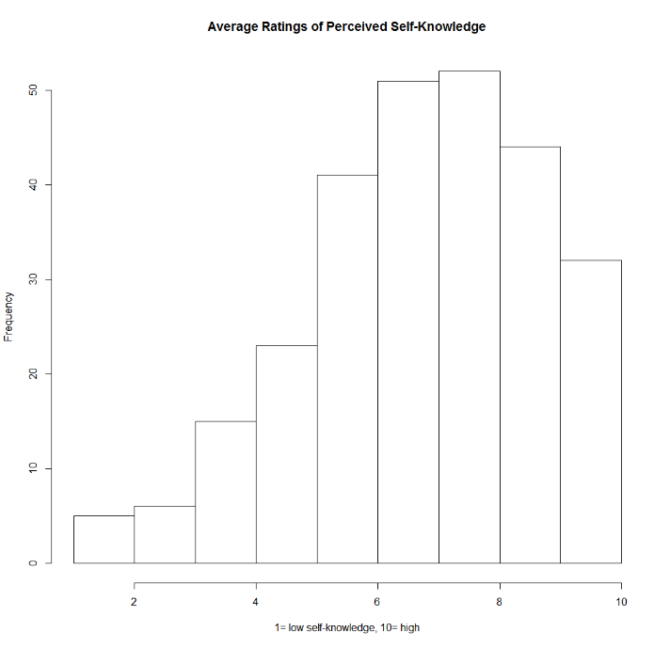

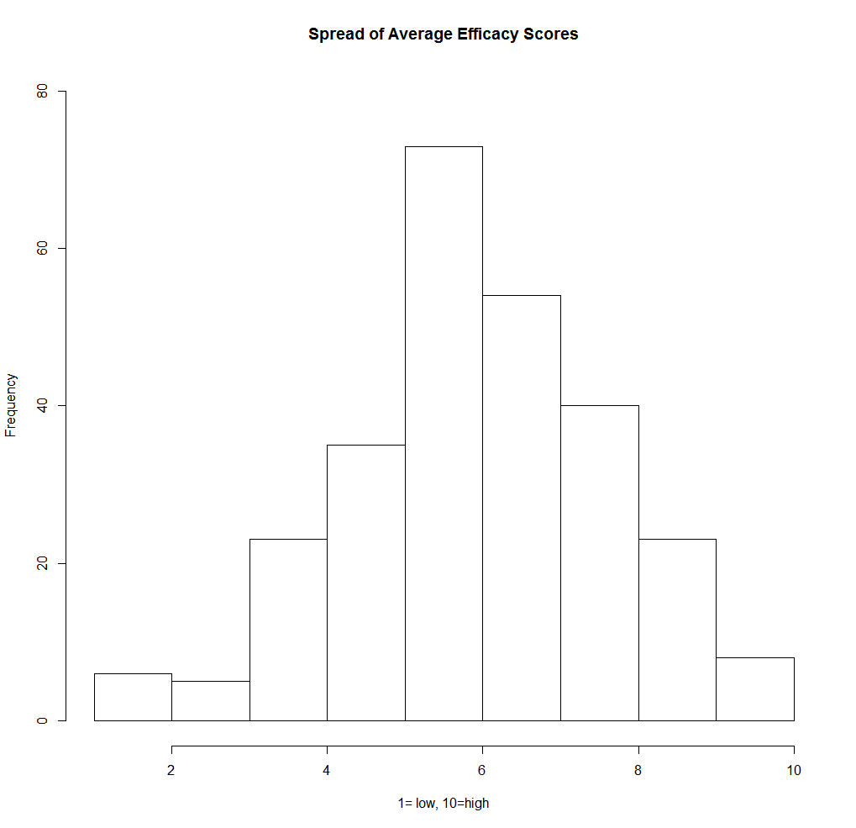

**References**

Achen, Christopher. 1975. “Mass Political Attitudes and the Survey Response.” *American Political Science Review* 69:1218-31.

Ansolabehere, Stephen, Jonathan Rodden and James M. Snyder, Jr. 2008. “The Strength of Issues: Using Multiple Measures to Gauge Preference Stability, Ideological Constraint, and Issue Voting.” *American Political Science Review* 102: 215-32.

Converse, Philip E. 1964. “The Nature of Belief Systems in Mass Publics.” In D. Apter, ed., *Ideology and Discontent*. New York: Free Press.

Delli Carpini, M.X. and Keeter, S. 1996. What Americans know about politics and why it matters. Yale University Press.

Gibson, James J., and Gregory A. Caldiera. 2009. “Knowing the Supreme Court? A Reconsideration of Public Ignorance of the High Court.” *Journal of Politics* 70: 429-41.

Graber, Doris. 2001. *Processing Politics: Learning from Television in an Internet Age.* Chicago: University of Chicago Press.

Jacoby, William G. 1995. “The Structure of Ideological Thinking in the American Electorate.” *American Journal of Political Science* 39:314-35.

Jerit, J., & Barabas, J. 2012. “Partisan Perceptual Bias and the Information Environment.” *The Journal of Politics*, 74: 672-684.

Kruger, J. and Dunning, D. 1999. “Unskilled and unaware of it: how difficulties in recognizing one's own incompetence lead to inflated self-assessments.” *Journal of personality and social psychology*, 77: p.1121-1134.

Luskin, R. C. 1990. Explaining Political Sophistication. *Political Behavior*, 12: 331-361.

Marcus, George E., David Tabb, and John L. Sullivan. 1974. “The Application of Individual Differences Scaling to the Measurement of Political Ideology.” *American Journal of Political Science* 18: 405-20.

Mondak, Jeffery J. 2001. “Developing Valid Knowledge Scales.” *American Journal of Political Science* 45 (1): 224-38

Nie, Norman, and Kristi Andersen. 1974. “Mass Belief Systems Revisited: Political Change and Attitude Structure.” *Journal of Politics* 36: 540-91.

Niemi, Richard G., Stephen C. Craig, and Franco Mattei. 1991. "Measuring internal political efficacy in the 1988 National Election Study." *American Political Science Review*, 85(4): 1407-1413.

Parker-Stephen, E., 2013. Tides of disagreement: How reality facilitates (and inhibits) partisan public opinion. *The Journal of Politics*, 75: 1077-1088.

Peffley, Mark, and Jon Hurwitz. 1985. “A Hierarchical Model of Attitude Constraint.” *American Journal of Political Science* 29:871-90.

Prior, Markus, and Arthur Lupia. 2008. "Money, Time, and Political Knowledge: Distinguishing Quick Recall and Political Learning Skills." *American Journal of Political Science,* 52:169-183.

Shaker, Lee. 2012. "Local Political Knowledge and Assessments of Citizen Competence." *Public Opinion Quarterly,* 76: 525-537.